Design and apply context-aware access controls based on user identity, device
posture, location, and application risk.

LIST OF TEAMMATES

TEAM ID: SWTID-2026-2034
TEAM MEMBERS: 4

S.NO | NAME | COLLEGE NAME | CONTACT
1 | GOLDA JERLIN B | Shri Nehru Maha vidyalaya college of arts and science, Coimbatore | goldajerlin19@gmail.com
2 | KEERTHIKA A | Shri Nehru Maha vidyalaya college of arts and science, Coimbatore | Keerthikeerthi40237@gmail.com
3 | KAVITHA K | Shri Nehru Maha vidyalaya college of arts and science, Coimbatore | gokulakannancbe2002@gmail.com
4 | SHOBANA G | Shri Nehru Maha vidyalaya college of arts and science, Coimbatore | shobanag667@gmail.com

TITLE : Design and Apply Context-Aware Access Controls Based on User Identity.
Introduction :
Context-aware access control is a security method that grants or restricts access based on
different contextual factors such as user identity, location, device, and time. It helps ensure that only
authorized users can access sensitive systems and data. By using user identity as a key factor,
organisations can improve security and manage access more effectively.
Abstract :
The increasing adoption of cloud services, mobile computing, and hybrid work models has fundamentally broken the traditional network perimeter, rendering legacy access control models ineffective. Organizations now struggle to protect sensitive data from a growing attack surface, where threats can originate from compromised endpoints, unsafe locations, or malicious insiders. Static, binary decisions (allow or deny) are no longer sufficient to mitigate the sophisticated risks present in modern distributed environments. There is a critical need for a dynamic security framework that can evaluate the full context of every access request in real-time.

This project presents the design and application of a context-aware access control system based on user identity, device posture, geolocation, and application risk. The objective is to develop a policy engine that ingests multiple contextual signals to calculate a real-time risk score for each access attempt. The methodology involves defining granular policies that map specific context combinations (e.g., "managed device" + "corporate network" + "low-risk app") to corresponding access decisions, such as granting full access, enforcing step-up authentication (MFA), limiting session functionality, or denying access entirely.

Use Case Scenarios:

    - Finance Department Access to ERP System
    - Contractor Access to Specific Project Repository
    - Executive Access to Sensitive Financial Documents
    - Remote Support Technician Access to Internal Tools
    - High-Risk Application Access from a Low-Trust Location

INTRODUCTION:
In an era where the digital landscape is constantly evolving, organizations face an ever-increasing threat from cyberattacks. The need for swift and effective incident response has become paramount to safeguard sensitive data, protect digital assets, and maintain the trust of stakeholders. In response to this growing challenge, we present a visionary project: the development of an AI-driven incident response platform that empowers cybersecurity teams with the tools to automate and enhance incident triage and response tasks.

The traditional network perimeter has all but dissolved in the modern digital landscape. With the mass adoption of cloud services, remote work, and personal mobile devices (BYOD), corporate resources are no longer confined to a single office building. This shift has rendered the conventional "castle-and-moat" security model—where anyone inside the network is trusted by default—obsolete and dangerously insufficient. Modern organizations now face the complex challenge of securing access to sensitive data from a diverse and ever-changing array of locations, devices, and user environments. To address this, security strategies must evolve from static, location-centric models to dynamic, identity-centric frameworks that assess the risk of every access request in real-time.

This project focuses on the design and implementation of a context-aware access control system to solve this exact challenge. By moving beyond simple username and password verification, this system will evaluate a rich set of contextual signals before granting access to applications and data. These signals include the user's identity and role, the security posture of their device (e.g., is it patched, encrypted, and managed?), their geographic location, and the inherent risk level of the application they are attempting to use. By analyzing these factors in unison, the system can make a granular, real-time decision: grant full access, restrict access to certain features, require step-up authentication (like multifactor authentication), or block the request entirely.

Ultimately, this project aims to build a security architecture that is both robust and frictionless. For example, a trusted employee accessing a low-risk application from a secured corporate laptop on the office network might have a seamless login experience. Conversely, that same employee attempting to access a critical financial system from an unpatched personal device in a foreign country would be met with additional security challenges or be completely blocked. This intelligent, adaptive approach not only significantly reduces the attack surface and protects against compromised credentials but also enables a secure and productive work environment for a modern, mobile workforce.

ABSTRACT:

The increasing adoption of cloud services, mobile computing, and hybrid work models has fundamentally broken the traditional network perimeter, rendering legacy access control models ineffective. Organizations now struggle to protect sensitive data from a growing attack surface, where threats can originate from compromised endpoints, unsafe locations, or malicious insiders. Static, binary decisions (allow or deny) are no longer sufficient to mitigate the sophisticated risks present in modern distributed environments. There is a critical need for a dynamic security framework that can evaluate the full context of every access request in real-time.

This project presents the design and application of a context-aware access control system based on user identity, device posture, geolocation, and application risk. The objective is to develop a policy engine that ingests multiple contextual signals to calculate a real-time risk score for each access attempt. The methodology involves defining granular policies that map specific context combinations (e.g., "managed device" + "corporate network" + "low-risk app") to corresponding access decisions, such as granting full access, enforcing step-up authentication (MFA), limiting session functionality, or denying access entirely.
The expected outcome is an adaptive security model that significantly reduces the organizational attack surface and mitigates the risk of credential compromise.

By ensuring that access decisions are dynamically aligned with the perceived threat level of each request, the system enhances security without introducing unnecessary friction for low-risk, trusted users. This approach provides a robust framework for enabling secure and productive access to resources in an increasingly perimeter-less and dynamic digital world.

Use Case Scenarios

Scenario 1: Finance Department Access to ERP System
A senior accountant in the finance department needs to access the corporate Enterprise Resource Planning (ERP) system to process monthly payroll. The user connects from a remote location using their company-managed laptop. Upon launching the ZPA Client Connector, they authenticate via Azure Active Directory with multi-factor authentication (MFA).
Output:
- User authenticated and authorized based on identity and group membership
- Direct micro-tunnel established specifically to the ERP application
- All other internal applications and network segments remain invisible and inaccessible

Scenario 2: Contractor Access to Specific Project Repository
An external software consultant is hired for a three-month project and requires access only to a specific Git repository hosted on an internal server. The contractor is onboarded as a guest user in the identity provider and assigned to the "Project_X_Contractors" groupTime-bound and role-specific access enforced
- Contractor restricted to a single application (Git repository)
- Lateral movement to adjacent systems completely blocked

Scenario 3: Executive Access to Sensitive Financial Documents
A company VP needs to access a folder containing confidential M&A documents stored in a corporate SharePoint site. The user connects from a hotel business center while traveling internationally, using their companymanaged tablet. Upon launching the ZPA Client Connector, they authenticate via Azure Active Directory with MFA. ZPA evaluates the user's identity, executive group membership, and device posture (which is compliant).
Output:
- User authenticated with MFA and device compliant, but flagged for unusual location
- Read-only access granted with download/print restrictions enforced
- Security team alerted to potential credential misuse or espionage attempt

Scenario 4: Remote Support Technician Access to Internal Tools
An IT support technician needs to access the corporate ServiceNow instance and a remote desktop tool to assist an employee. The technician connects from their home office using a company-managed desktop.

Output:
- User authenticated and fully authorized based on trusted context
- Direct micro-tunnels established to ServiceNow and the remote desktop jump host
- Least-privilege access maintained; unrelated internal systems remain invisible

Scenario 5: High-Risk Application Access from a Low-Trust Location
A marketing coordinator needs to access the corporate Salesforce instance to update a campaign. The user connects from a coffee shop using their company-managed smartphone. Upon launching the ZPA Client Connector, they authenticate via Azure Active Directory with MFA. ZPA evaluates the user's identity, group membership (Marketing_Salesforce_Users), device posture (managed and compliant), but flags the public Wi-Fi network as a high-risk connection
Output:
- User authenticated and device compliant, but network location deemed high-risk
- Access granted via browser isolation to prevent data leakage on public Wi-Fi
- Session is rendered in a secure container with copy/paste and download controls enforced
Stage – 1

Title:
Design and apply context-aware access controls based on user identity, device posture, location, and application risk.
Overview:
In response to the evolving threat landscape and the dissolution of the traditional network perimeter, modern enterprises are rapidly shifting away from legacy VPN-centric remote access models. These conventional approaches often grant excessive network-level access, creating a significant attack surface and increasing the risk of lateral threat movement. To address these challenges, this project centers on the implementation of a Zero Trust security architecture, fundamentally operating on the principle of "never trust, always verify." By moving beyond location-based access, we aim to establish a security posture where trust is no longer implicit, and access is determined by granular context rather than network connectivity.

Ultimately, this project will enforce a least-privilege access model, ensuring users and devices are granted the minimum required access necessary to perform their functions. By decoupling application access from network access, we will eliminate the risk of lateral movement across the network, as users have no visibility or connectivity to other hosts. This strategic move not only significantly enhances security by reducing the attack surface but also simplifies the user experience and reduces operational overhead associated with legacy remote access infrastructure, positioning the organization at the forefront of secure and efficient access management.

List of Vulnerability:

S. No. | Vulnerability Name | CWE No.
1. | Cross-site scripting (stored) | 79
2. | Broken Access Control | 285
3. | SQL Injection | 89
4. | Broken Authentication | 285
5. | Insecure Direct Object Reference | 639
6. | Security Misconfiguration | 732
7. | Cross-Site Request Forgery | 352
8. | Cleartext Transmission of Sensitive Information | 319
9. | ClickJacking | 1021
10. | webserver allows password auto-completion | 310
Report:
1. Vulnerability name: Cross site scripting (stored)
CWE: 79
OWASP category: A03:2021 -Injections
Description: It occurs when a malicious script is injected directly into a vulnerable web application.
Vulnerability path: http://testfire.net/

Vulnerability parameter: http://testfire.net/search.jsp?query=%27%3E%3Cscript%3Ealert%28%27hacked%27%29%3C%2Fscrip t%3E

Steps to Reproduce:
- Access the URL
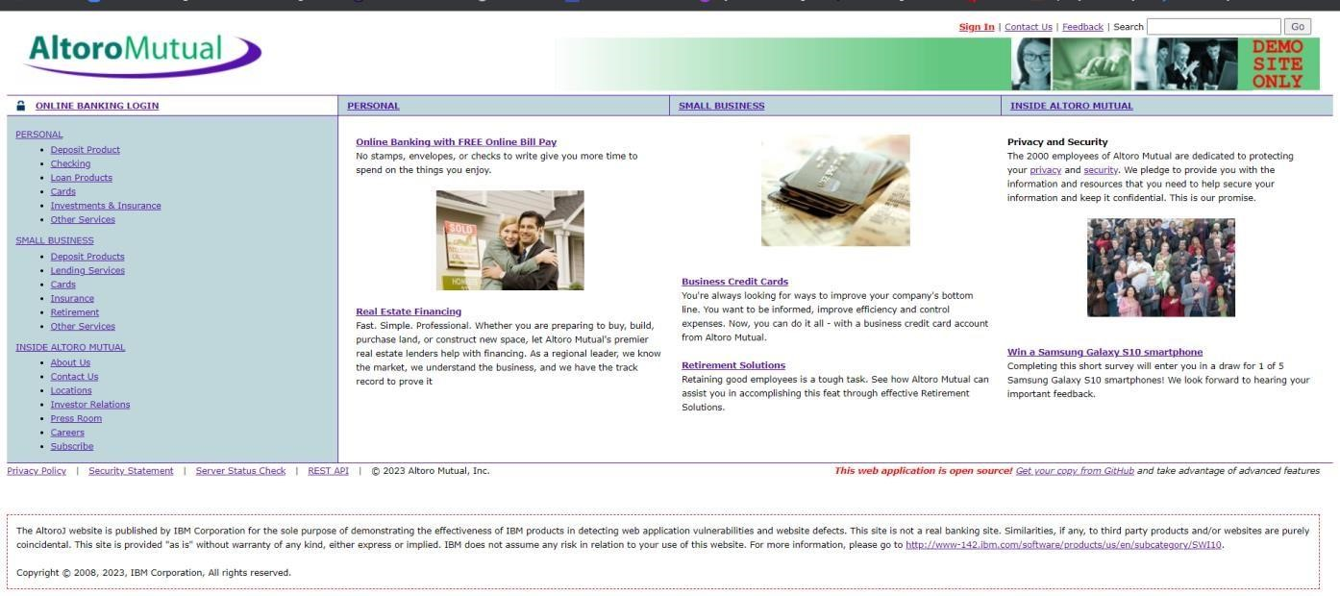

- In the search box we will input some code to perform the vulnerability.
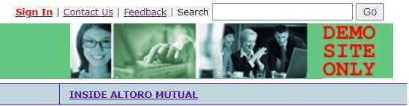

- The Script we will be inputting is '><script>alert('hacked')</script>
- This displays a harmless pop up alert box with the text saying ‘hacked’

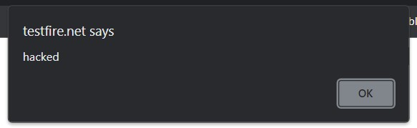

Recommendation:
- When interacting with databases, use parameterized statements or prepared statements to avoid SQL injection, which can be a vector for XSS.
- Sanitize and validate all user inputs and ensure that any data displayed on the web page is properly encoded. Use output encoding libraries or functions to prevent script injection.

- Vulnerability name: Broken access control
CWE: 285
Description: When access control checks are not applied consistently - or not at all - users are able to access data or perform actions that they should not be allowed to perform. This can lead to a wide range of problems, including information exposures, denial of service, and arbitrary code execution.

Business Impact: wide-ranging business impact, including financial losses, reputation damage, legal consequences, operational disruption, and loss of customer trust. Addressing this vulnerability is crucial to protect the organization and its stakeholders from these potential negative effects.

Vulnerability path: http://testfire.net/
Vulnerability parameter: http://testfire.net/login.jsp

Steps to Reproduce:

  - Access the URL


  - Now we will try to sign in to this website with admin privileges

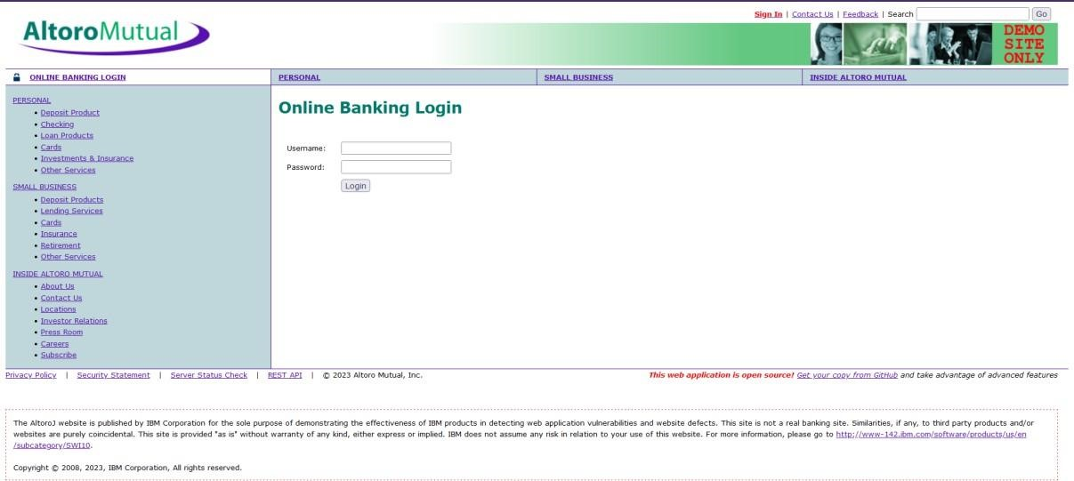
  - Also, we will be using burp suite to get requests from the website and know additional information. We use ‘admin’ for the username and password.

  - as well.
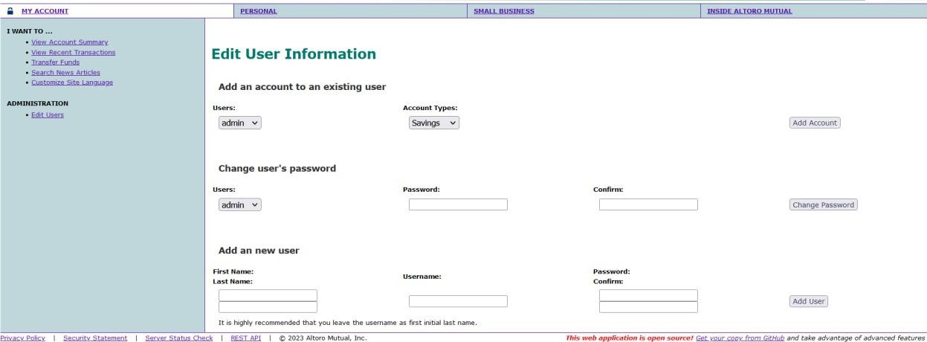

Recommendations:
  - Ensure that the application has a robust authentication and authorization mechanism in place. Users should be authenticated before any sensitive actions are performed, and authorization checks should be conducted to verify that users have the necessary permissions for the requested operation.
  - Ensure that session management is secure. Use strong session IDs, enforce session timeouts, and regenerate session tokens after login. Implement session fixation protection to prevent session hijacking.

- Vulnerability name: SQL injection
CWE: 89
Description: The product constructs all or part of an SQL command using externally-influenced input from an upstream component, but it does not neutralize or incorrectly neutralizes special elements that could modify the intended SQL command when it is sent to a downstream component.
Business Impact: In summary, it is crucial to underscore that CWE-89, known as SQL Injection, can exert a profound and diverse business impact. This encompasses critical facets such as data breaches, financial setbacks, harm to reputation, legal ramifications, and operational turmoil. Hence, the imperative of preventing and remedying SQL injection vulnerabilities cannot be overstated, as it is indispensable for fortifying the security and continuity of an organization's applications and data.
Vulnerability path: http://testfire.net/
Vulnerability parameter: http://testfire.net/login.jsp

Steps to Reproduce:

- Access the URL

- Now we will try to sign in to this website with admin privileges but using SQL injection



- Also, we will be using burp suite to get requests from the website and know additional information.
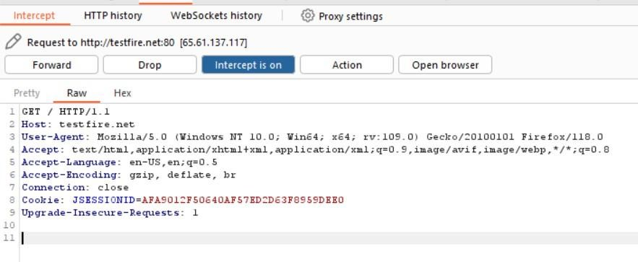

- With this we can know that sql injection worked and we got the admin privileges.

Recommendations:
- If parameterized statements are not feasible, use proper input validation and escaping mechanisms to sanitize user inputs before they are used in SQL queries. This helps prevent malicious code injection.
- Utilize stored procedures for database operations. This can help separate SQL code from application code and reduce the risk of SQL injection.
- Implement strict input validation for all user inputs, ensuring that data adheres to the expected format and structure.
4. Vulnerability name: Broken authentication
CWE: 285
Description: The system's authorization functionality does not prevent one user from gaining access to another user's data or record by modifying the key value identifying the data.

Business Impact: To effectively mitigate the business impact of CWE-285, it is imperative that organizations place a strong emphasis on bolstering their authentication and session management practices. This should encompass the adoption of multi-factor authentication, the secure storage of credentials, meticulous session handling, and a commitment to conducting routine security assessments and testing. The rectification of these vulnerabilities stands as a critical imperative, safeguarding sensitive data, user identities, and the organization's overarching security stature and reputation.

Vulnerability path: http://testfire.net/

Vulnerability parameter: http://testfire.net/login.jsp

Steps to Reproduce:

- Access the URL



- Now we will try to login using some different approach.

Recommendations:
- Implement strong authentication mechanisms, such as multi-factor authentication (MFA) or two- factor authentication (2FA), to ensure that only authorized users can access the system.
- Implement proper authorization controls to ensure that users have the necessary permissions to access specific functions or data. Use role-based access control (RBAC) to manage user privileges effectively.
- Deploy intrusion detection and prevention systems (IDS/IPS) to monitor and block suspicious activities related to authentication and authorization.
5. Vulnerability Name: Insecure Direct object Reference
CWE: 639
OWASP Category: A01: Broken Access Control

Description:
Insecure Direct Object Reference (IDOR) is a vulnerability that arises when attackers can access or modify objects by manipulating identifiers used in a web application's URLs or parameters. It occurs due to missing access control checks, which fail to verify whether a user should be allowed to access specific data.
Business Impact:
To effectively mitigate the business impact of CWE-639, organizations must make it a top priority to fortify their access control and authorization mechanisms. This entails the implementation of robust security measures, the regular conduct of comprehensive security assessments, and the deployment of intrusion detection systems to promptly identify and counter unauthorized access attempts. These measures stand as absolutely critical in the defense of sensitive data, the overall security of systems, and the preservation of the organization's esteemed reputation.

Vulnerability Path: http://testfire.net
Vulnerability Parameter: http://testfire.net/bank/transfer.jsp

Steps to Reproduce:

- Go to the domain. ➢ Sign into the site.
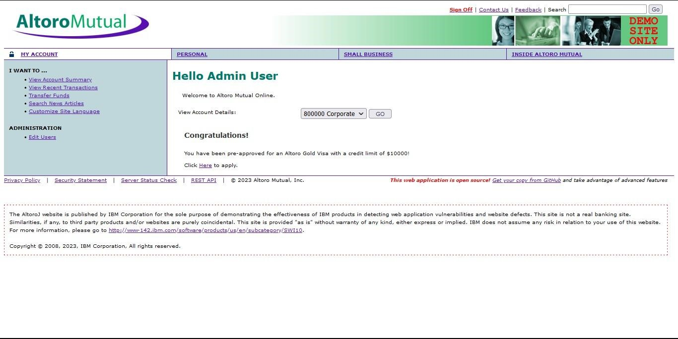
- Open “Transfer Money” on the left side and fill in the details. On the intercept and click transfer
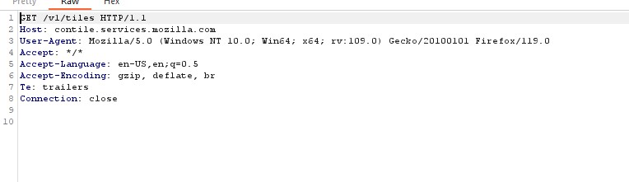
- Look at the site, we can notice the msg that shows the transfer of 1000.

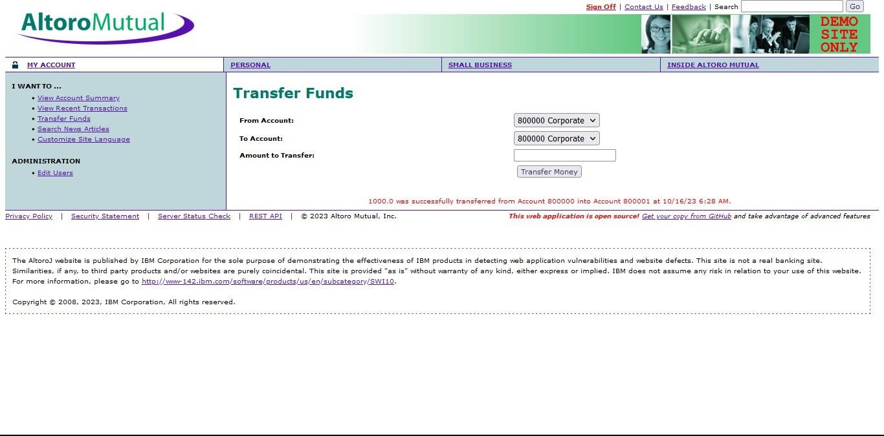

- Off the Intercept and open “View Recent Transactions”.

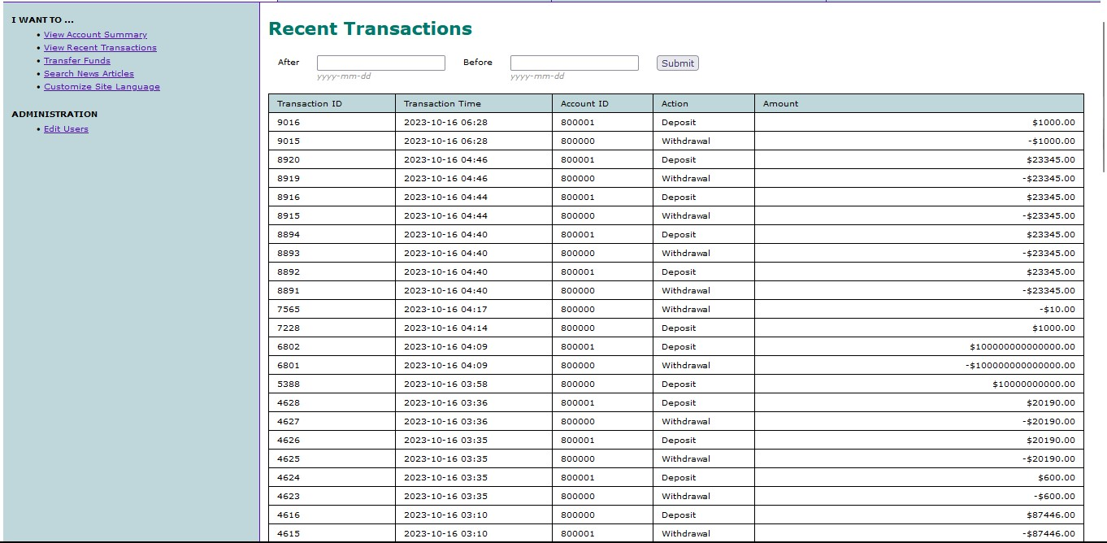

Recommendation:
  - Utilize parameterized queries or prepared statements when interacting with databases. This prevents user-controlled input from being executed as SQL code.
  - Implement a Content Security Policy to mitigate the risk of cross-site scripting (XSS) attacks, which can be used to execute unauthorized queries.
  - Implement account lockout mechanisms that temporarily suspend accounts after a specified number of unauthorized access attempts to prevent brute force attacks.
6. Vulnerability name: Security Misconfiguration
CWE:732
Description: The product specifies permissions for a security-critical resource in a way that allows that resource to be read or modified by unintended actors.
Business Impact: To effectively lessen the business consequences stemming from CWE-732, organizations must place a strong emphasis on bolstering their configuration management practices. This involves the establishment of secure default settings, the routine conduct of comprehensive security evaluations, and the deployment of intrusion detection systems to promptly detect and address misconfigurations and vulnerabilities. These actions are of paramount importance in safeguarding sensitive data, fortifying system security, and preserving the organization's esteemed reputation.

Vulnerability path: http://testfire.net/
Vulnerability parameter: http://testfire.net/login.jsp

Steps to Reproduce:

- Access the URL



- We will be using the uniscan tool which is available in the kali.

- We will use this tool to scan for hidden directories that can be access due to poor security measures taken in this website.
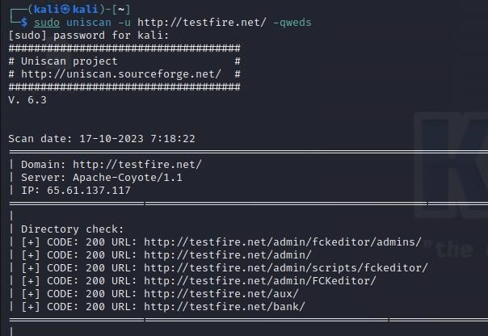

- We found directories that can be accessed easily. Also all the files that are present in the website has also been found.

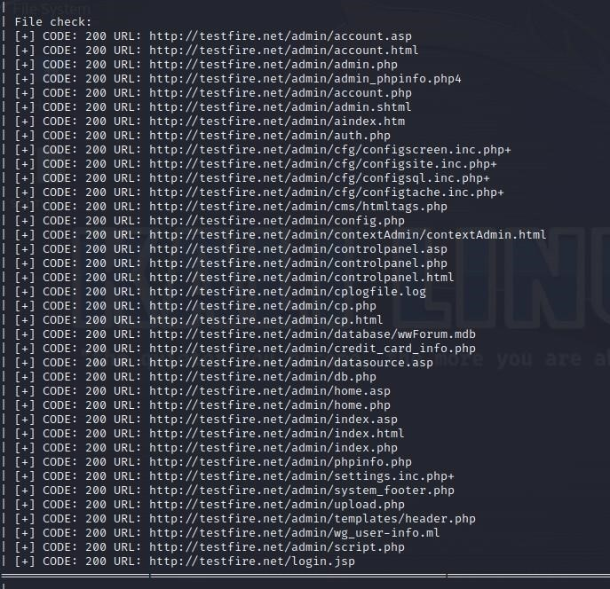

- Let us go through one webpage to see the vulnerability
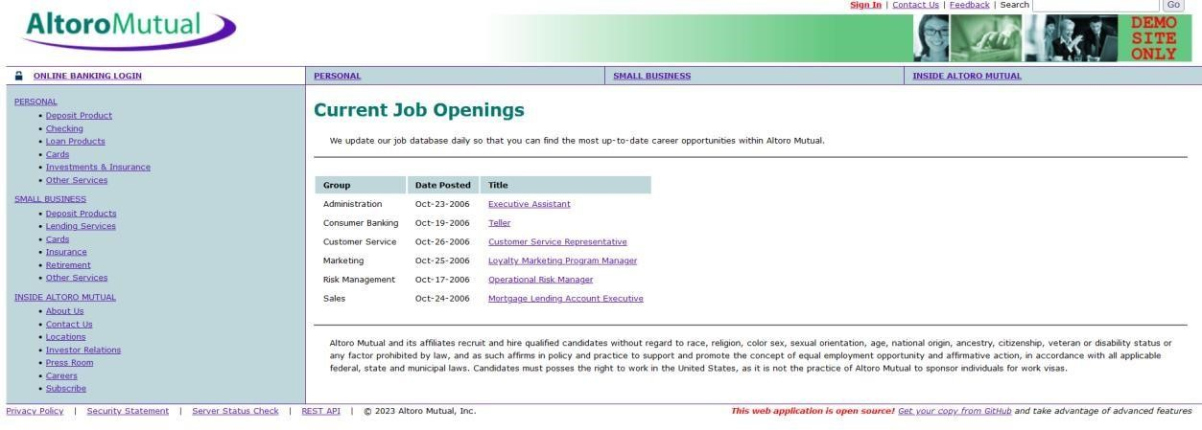

- Here we can see the sensitive data of job applications which can help an attacker.

Recommendations:
- Implement a change management process to document and review all changes to system configurations. This helps prevent unauthorized or unintended alterations.
- Follow security guidelines provided by software and hardware vendors to ensure secure configurations.
- Regularly perform compliance checks against industry standards and regulations to ensure that configurations remain in compliance with security requirements.

7. Vulnerability Name: Cross-Site Request Forgery
CWS: 352
OWASP Category: A08: Cross-Site Request Forgery
Description:
Cross-Site Request Forgery (CSRF) is an attack that forces an end user to execute unwanted actions on a web application in which they’re currently authenticated. With a little help of social engineering (such as sending a link via email or chat), an attacker may trick the users of a web application into executing actions of the attacker’s choosing. If the victim is a normal user, a successful CSRF attack can force the user to perform state changing requests like transferring funds, changing their email address, and so forth. If the victim is an administrative account, CSRF can compromise the entire web application.
Business Impact:

To effectively reduce the business repercussions of CWE-352, organizations must prioritize secure coding practices, including the incorporation of anti-CSRF tokens, while also conducting routine security assessments and testing to detect and rectify CSRF vulnerabilities. Furthermore, educating users on secure browsing practices is pivotal in preventing CSRF attacks. These actions are of paramount importance in the protection of data and in upholding the trust of customers and partners.

Vulnerability Path: http://testfire.net/
Vulnerability Parameter: http://testfire.net/bank/transfer.jsp
Steps to Reproduce:

- Open https://testfire.net/.
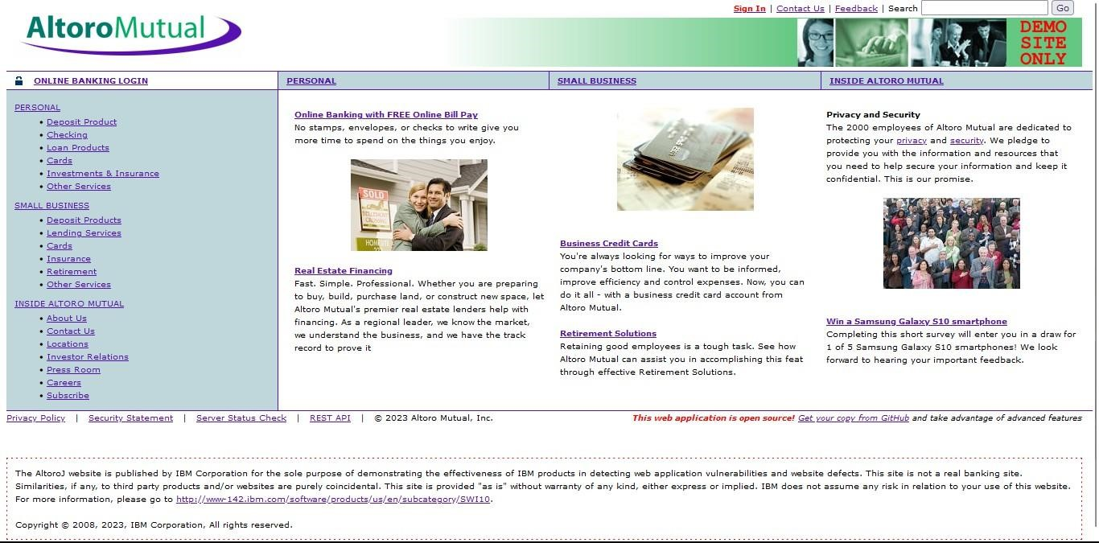

- Login to it using default credentials, and you will find two accounts.

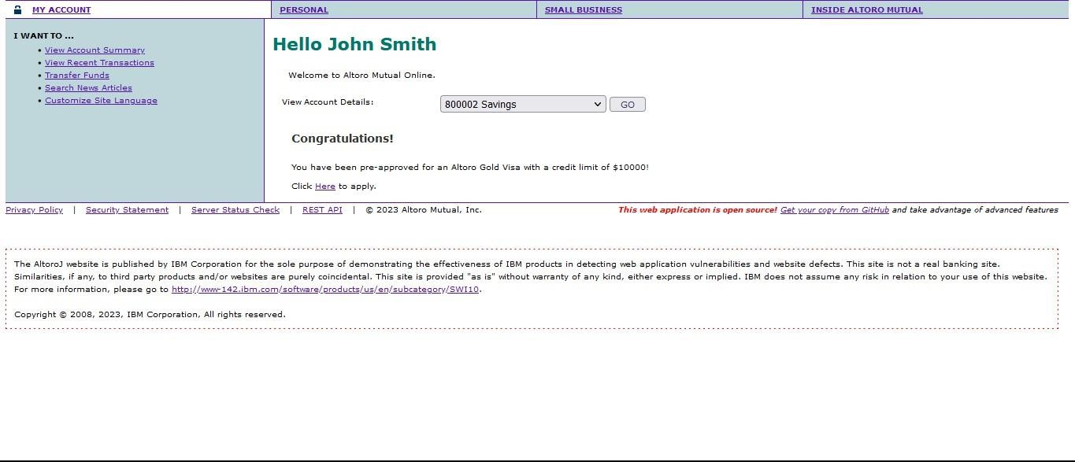

- Capture the request in any Intercepting proxy (Burp Suite, Charles Proxy etc.) while transferring the amount from one account to another as shown in the below picture.

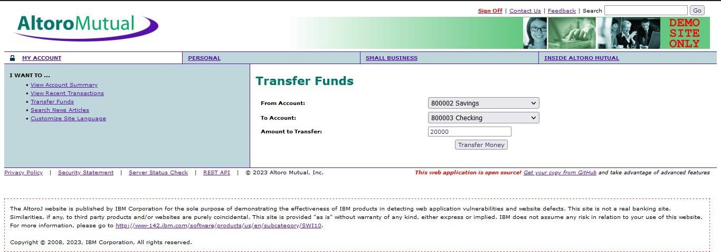
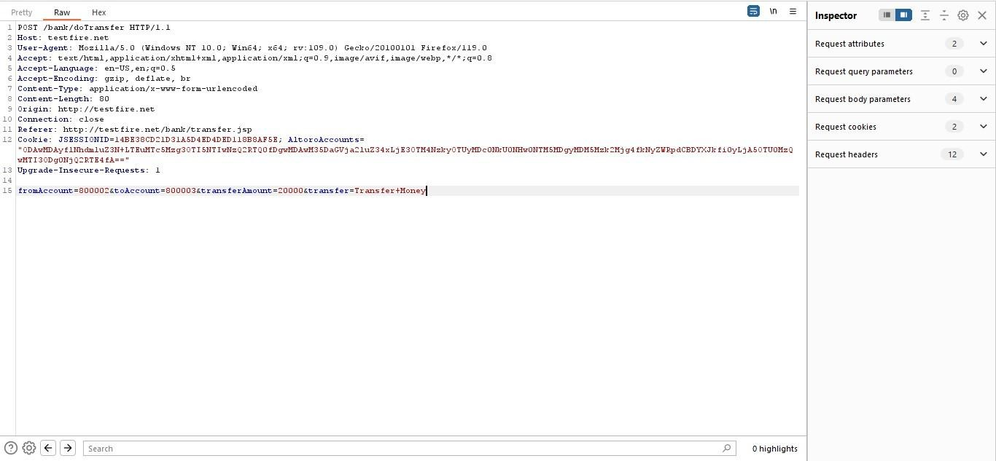

- Generate CSRF POC using Burp Suite Engagement tools (by modifying the account numbers accordingly)

- Implement a Content Security Policy to restrict the sources from which various types of content can be loaded. By specifying the trusted sources of content, you can minimize the risk of malicious code execution and reduce the likelihood of successful CSRF attacks.
8. Vulnerability name: Cleartext Transmission of Sensitive Information
CWE: 319
Description: The product transmits sensitive or security-critical data in cleartext in a communication channel that can be sniffed by unauthorized actors. Many communication channels can be "sniffed" (monitored) by adversaries during data transmission. For example, in networking, packets can traverse many intermediary nodes from the source to the destination, whether across the internet, an internal network, the cloud, etc. Some actors might have privileged access to a network interface or any link along the channel, such as a router, but they might not be authorized to collect the underlying data. As a result, network traffic could be sniffed by adversaries, spilling security-critical data.
Business Impact: To effectively reduce the business consequences associated with CWE-319, organizations must prioritize the adoption of secure data transmission practices. This includes the utilization of encryption and robust, secure protocols. The routine conduct of security assessments and testing is pivotal in pinpointing and remedying vulnerabilities linked to data transmission. Furthermore, the education of users on secure data handling practices plays a vital role in proactively preventing data exposure incidents. These actions are of paramount importance in the protection of sensitive data and in preserving the trust of both customers and partners.
Vulnerability path: http://testfire.net/
Vulnerability parameter: http://testfire.net/login.jsp

Steps to reproduce:
- Access the URL


- Now we will try to sign in to this website with admin privileges
- manipulated as well.

Recommendations:
- Educate users and employees on secure data handling practices, such as recognizing secure websites (look for "https") and avoiding insecure Wi-Fi networks.
- Employ data masking or redaction techniques to replace sensitive data with placeholders or cryptographic representations during transmission.
- Implement encryption for data in transit. Use secure encryption protocols such as TLS/SSL to protect sensitive information during transmission.
- Use secure communication protocols for transmitting data, such as HTTPS for web applications, and ensure that the selected protocols are kept up-to-date.

9. Vulnerability name: Click Jacking
CWE: 1021
Description: The web application does not restrict or incorrectly restricts frame objects or UI layers that belong to another application or domain, which can lead to user confusion about which interface the user is interacting with.
Business Impact: To effectively reduce the business consequences resulting from CWE-1021, organizations must prioritize the implementation of protective measures, such as frame-busting code. Simultaneously, educating users on safe browsing practices plays a crucial role in preventing clickjacking incidents. Additionally, routine security assessments and testing are pivotal for identifying and mitigating vulnerabilities associated with clickjacking. These actions are of paramount importance in upholding user trust, ensuring data protection, and safeguarding the organization's reputation.
Vulnerability path: http://testfire.net/

Vulnerability parameter: http://testfire.net/
Steps to reproduce:
- Access the URL


- Then take the URL and use it for the html code
- we will be writing some html code to perform this vulnerability. we will be writing the code in vs code for better flexibility and functionality.

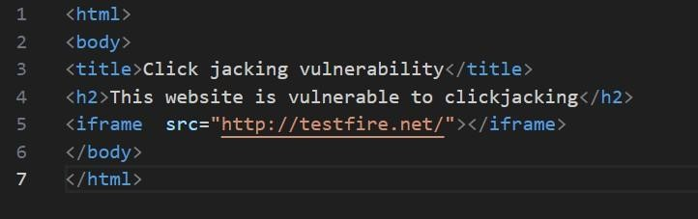

- After the code has been written then we will be executing the code in the browser.
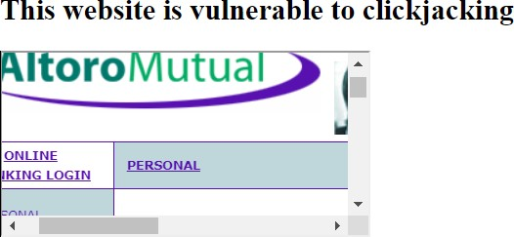

- From this image we can see that the vulnerability has been found.
Recommendation:
- Set the X-Frame-Options HTTP response header to deny or same-origin to control how your site can be framed. This is supported by most modern browsers.
- Utilize frame-busting JavaScript code in web applications to prevent the embedding of your site within malicious iframes. This code can disrupt clickjacking attempts.
- Implement a Content Security Policy to restrict which domains can embed your site in iframes. This can help prevent unauthorized framing.
- Implement additional security controls to prevent UI redress attacks, such as clickjacking, within your web application.
10. Vulnerability name: web server allows password auto-completion
CWE: 310
Description:
Weaknesses in this category are related to the design and implementation of data confidentiality and integrity. Frequently these deal with the use of encoding techniques, encryption libraries, and hashing algorithms. The weaknesses in this category could lead to a degradation of the quality data if they are not addressed.
Business impact:
To effectively lessen the business consequences associated with CWE-310, organizations must prioritize the adoption of secure cryptographic practices. This entails ensuring proper password storage and robust encryption key management. Simultaneously, conducting routine security assessments and testing is pivotal in detecting and mitigating vulnerabilities related to cryptographic issues. Striving for compliance with pertinent data protection regulations and industry standards is equally essential. These actions are of paramount importance in the protection of sensitive data, the upholding of user trust, and the preservation of the organization's esteemed reputation.
Vulnerability path: http://testfire.net/

Vulnerability parameter: http://testfire.net/login.jsp
Steps to reproduce:
- Access the URL

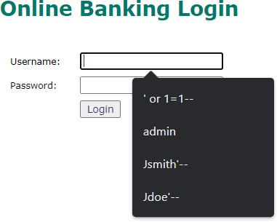

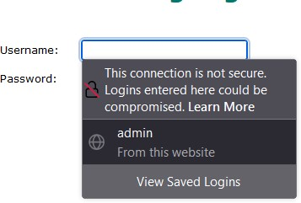

- From this image we can see the usernames and the passwords getting auto filled. This is a potential vulnerability as this can be a doorway for attackers.
Responsibilities:
- Implement secure password storage mechanisms, such as using strong and salted cryptographic hashing algorithms like bcrypt or scrypt.
- Implement robust encryption key management practices, including secure key storage, key rotation, and access controls.

NESSUS SCAN REPORT:

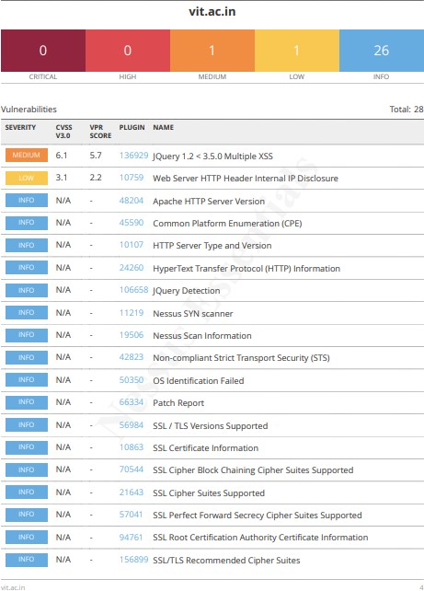

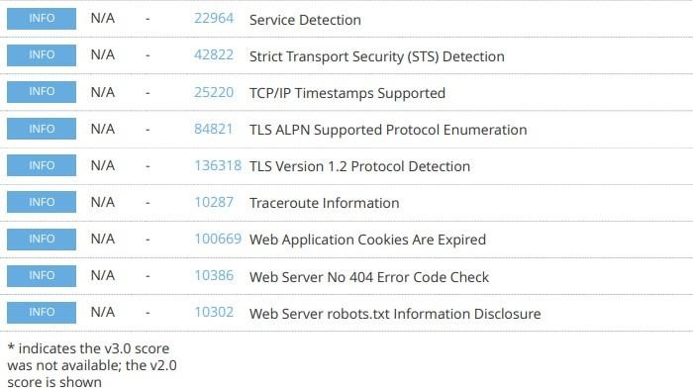

"With the Nessus scan report now at our disposal, we're equipped with critical data on the existing vulnerabilities and potential threats. This invaluable information will serve as a foundation for our project planning phase, as we chart the course to develop our AI-driven incident response platform with a well- informed strategy and timeline."
Stage – 2

Overview: -
An overview of a Nessus scan typically involves the following key steps and aspects:

- Preparation: Define Objectives: Determine the scope and objectives of the scan. What systems or networks do you want to assess, and what specific vulnerabilities are you looking for?

System Access: Ensure that you have the necessary permissions and access rights to scan the target systems or networks.
- Configuration: Set Up Scan Policy: Create a scan policy that defines the parameters of the scan, such as the types of vulnerabilities to check for, scanning frequency, and specific configurations.
Define Target Assets: Specify the IP addresses, hostnames, or network ranges of the systems you want to scan.

- Scanning: Initiate Scan: Start the Nessus scan using the configured policy and target assets. Nessus will systematically scan the target systems for vulnerabilities based on its plugins and policies.

- Vulnerability Identification: Nessus performs a comprehensive assessment, checking for vulnerabilities, misconfigurations, open ports, and other security issues. As the scan progresses, it categorizes vulnerabilities by severity, making it easier to prioritize remediation efforts.
Nessus scans are a critical component of proactive security, helping organizations identify and address vulnerabilities in their IT infrastructure to reduce the risk of security breaches and data compromises. The frequency and depth of scans can vary depending on an organization's security strategy and requirements.
Nessus is a popular vulnerability scanning tool used for identifying security weaknesses in computer systems and networks. It is widely utilized by security professionals and organizations to assess the security posture of their systems and to proactively identify potential vulnerabilities that could be exploited by attackers. Here's what I understand about Nessus scans:
  - Vulnerability Assessment: Nessus performs a vulnerability assessment by scanning target systems or networks to identify security issues, such as missing patches, misconfigurations, weak passwords, and other potential weaknesses that could be exploited by attackers.
  - Network Scanning: Nessus can scan a wide range of network devices, including servers, routers, switches, firewalls, and more. It examines network services, open ports, and software running on target systems.

  - Plugin Architecture: Nessus uses a plugin-based architecture, allowing it to check for a wide variety of vulnerabilities. These plugins are regularly updated to include the latest security checks and support for new vulnerabilities.
  - Compliance Auditing: It can also be used to assess systems against various compliance standards and regulatory requirements, helping organizations ensure that their systems meet specific security standards, like PCI DSS or CIS benchmarks.
  - Customization: Nessus scans can be customized to suit the specific needs of an organization. Users can define scan policies, select the target systems, and specify the types of vulnerabilities to scan for.

  - .
It's important to note that Nessus is a valuable tool for identifying vulnerabilities, but it doesn't fix these vulnerabilities itself. It's up to the organization's IT and security teams to take the necessary steps to remediate the identified issues to enhance their security.

S. No | Vulnerability Name | Severity | Plugins
1. | Cross-site scripting (stored) | Low | Web application Scanner
2. | Broken Access Control | Medium | SSH weak HMAC Algorithms Supported
3. | SQL Injection | Medium | N/A
4. | Broken Authentication | Low | HSTS Missing from Server
5. | Insecure Direct Object Reference | Info | Service Detection
6. | Security Misconfiguration | Low | SSL cipher Block Chaining cipher suites
7. | Cross-Site Request Forgery | Low | HTTP Form- Based Authentication  Detected
8. | Cleartext Transmission of Sensitive Information | Medium | Cleartext Transmission of Sensitive Information over HTTP
9. | ClickJacking | Info | HTML Rendering Layer Vulnerability
10. | webserver allows password auto- completion | Low | SSL/TLS Diffie-Hellman Modulus<=1024 bits(Logjam)

Target Website: testfire.net

Target IP Address: 54.83.41.36

Report:

- VULNERABILITY NAME: Cross site scripting (stored)
SEVERITY: Low
PLUGIN: web application scanner
PORT: N/A
DESCRIPTION: It occurs when a malicious script is injected directly into a vulnerable web application. Reflected XSS involves the reflection of a malicious script of a web application, onto a user's browser.

SOLUTION:
  - When interacting with databases, use parameterized statements or prepared statements to avoid SQL injection, which can be a vector for XSS.
  - Sanitize and validate all user inputs and ensure that any data displayed on the web page properly encoded. Use output encoding libraries or functions to prevent script injection.

BUSINESS IMPACT: The application stores dangerous data in a database, message forum, visitor log, or other trusted data store. Later, the dangerous data is subsequently read back into the application and included in dynamic content. From an attacker's perspective, the optimal place to inject malicious content is in an area that is displayed to either many users or particularly interesting users. Interesting users typically have elevated privileges in the application or interact with sensitive data that is valuable to the attacker. If one of these users executes malicious content, the attacker may be able to perform privileged operations on behalf of the user or gain access to sensitive data belonging to the user.

- VULNERABILITY NAME: Broken access control
SEVERITY: medium
PLUGIN: SSH weak HMAC Algorithms supported
PORT: N/A
DESCRIPTION: When access control checks are not applied consistently - or not at all - users are able to access data or perform actions that they should not be allowed to perform. This can lead to a wide range of problems, including information exposures, denial of service, and arbitrary code execution.

SOLUTION:
  - Ensure that the application has a robust authentication and authorization mechanism in place. Users should be authenticated before any sensitive actions are performed, and authorization checks should be conducted to verify that users have the necessary permissions for the requested operation.
  - Ensure that session management is secure. Use strong session IDs, enforce session timeouts, and regenerate session tokens after login. Implement session fixation protection to prevent session hijacking.

BUSINESS IMPACT: wide-ranging business impact, including financial losses, reputation damage, legal consequences, operational disruption, and loss of customer trust. Addressing this vulnerability is crucial to protect the organization and its stakeholders from these potential negative effects.

- VULNERABILITY NAME: SQL injection

SEVERITY: medium

PLUGIN: N/A (typically would be a security testing tool)
PORT: port 80/443
DESCRIPTION: The product constructs all or part of an SQL command using externally influenced input from an upstream component, but it does not neutralize or incorrectly neutralizes special elements that could modify the intended SQL command when it is sent to a downstream component.

SOLUTION:
  - If parameterized statements are not feasible, use proper input validation and escaping mechanisms to sanitize user inputs before they are used in SQL queries. This helps prevent malicious code injection.
  - Utilize stored procedures for database operations. This can help separate SQL code from application code and reduce the risk of SQL injection.
  - Implement strict input validation for all user inputs, ensuring that data adheres to the expected format and structure.

BUSINESS IMPACT: In summary, it is crucial to underscore that CWE-89, known as SQL Injection, can exert a profound and diverse business impact. This encompasses critical facets such as data breaches, financial setbacks, harm to reputation, legal ramifications, and operational turmoil. Hence, the imperative of preventing and remedying SQL injection vulnerabilities cannot be overstated, as it is indispensable for fortifying the security and continuity of an organization's applications and data.

- VULNERABILITY NAME: Broken authentication
SEVERITY: Low
PLUGIN: HSTS Missing from HTTPS Server (plugin id:142960)
PORT: port 443
DESCRIPTION: The system's authorization functionality does not prevent one user from gaining access to another user's data or record by modifying the key value identifying the data.

SOLUTION:
  - Implement strong authentication mechanisms, such as multi-factor authentication (MFA) or two-factor authentication (2FA), to ensure that only authorized users can access the system.
  - Implement proper authorization controls to ensure that users have the necessary permissions to access specific functions or data. Use role-based access control (RBAC) to manage user privileges effectively.
  - Deploy intrusion detection and prevention systems (IDS/IPS) to monitor and block suspicious activities related to authentication and authorization.

BUSINESS IMPACT: To effectively mitigate the business impact of CWE-285, it is imperative that organizations place a strong emphasis on bolstering their authentication and session management practices. This should encompass the adoption of multi-factor authentication, the secure storage of credentials, meticulous session handling, and a commitment to conducting routine security assessments and testing. The rectification of these vulnerabilities stands as a critical imperative, safeguarding sensitive data, user identities, and the organization's overarching security stature and reputation.

- VULNERABILITY NAME: Insecure Direct object Reference
SEVERITY: Info
PLUGIN: Service Detection (plugin id:22964)
PORT: port 80/443
DESCRIPTION: Insecure Direct Object Reference (IDOR) is a vulnerability that arises when attackers can access or modify objects by manipulating identifiers used in a web application's URLs or parameters. It occurs due to missing access control checks, which fail to verify whether a user should be allowed to access specific data.

SOLUTION:
  - Utilize parameterized queries or prepared statements when interacting with databases. This prevents user-controlled input from being executed as SQL code.
  - Implement a Content Security Policy to mitigate the risk of cross-site scripting (XSS) attacks, which can be used to execute unauthorized queries.
  - Implement account lockout mechanisms that temporarily suspend accounts after a specified number of unauthorized access attempts to prevent brute force attacks.

BUSINESS IMPACT: To effectively mitigate the business impact of CWE-639, organizations must make it a top priority to fortify their access control and authorization mechanisms. This entails the implementation of robust security measures, the regular conduct of comprehensive security assessments, and the deployment of intrusion detection systems to promptly identify and counter unauthorized access attempts. These measures stand as critical in the defence of sensitive data, the overall security of systems, and the preservation of the organization's esteemed reputation.

- VULNERABILITY NAME: Security Misconfiguration
SEVERITY: low

PLUGIN: SSL cipher Block chaining cipher suites
PORT: port 443
DESCRIPTION: The product specifies permissions for a security-critical resource in a way that allows that resource to be read or modified by unintended actors.

SOLUTION:
  - Implement a change management process to document and review all changes to system configurations. This helps prevent unauthorized or unintended alterations.
  - Follow security guidelines provided by software and hardware vendors to ensure secure configurations.
  - Regularly perform compliance checks against industry standards and regulations to ensure that configurations remain in compliance with security requirements.

BUSINESS IMPACT: To effectively lessen the business consequences stemming from CWE-732, organizations must place a strong emphasis on bolstering their configuration management practices. This involves the establishment of secure default settings, the routine conduct of comprehensive security evaluations, and the deployment of intrusion detection systems to promptly detect and address misconfigurations and vulnerabilities. These actions are of paramount importance in safeguarding sensitive data, fortifying system security, and preserving the organization's esteemed reputation.

- VULNERABILITY NAME: Cross-Site Request Forgery SEVERITY: Low
PLUGIN: HTTP Form-Based Authentication Detected
PORT: port 8080/443
DESCRIPTION: Cross-Site Request Forgery (CSRF) is an attack that forces an end user to execute unwanted actions on a web application in which they’re currently authenticated. With a little help of social engineering (such as sending a link via email or chat), an attacker may trick the users of a web application into executing actions of the attacker’s choosing. If the victim is a normal user, a successful CSRF attack can force the user to perform state changing requests like transferring funds, changing their email address, and so forth. If the victim is an administrative account, CSRF can compromise the entire web application.

SOLUTION:
  - Implement Synchronizer Token Patterns to include unique, randomly generated tokens in each HTTP request and validate these tokens on the server side to verify the authenticity of the request.
  - Utilize the Same Site attribute in cookies to restrict their usage to same-site requests only, preventing them from being sent along with cross-site requests and effectively mitigating CSRF attacks.
  - Utilize framework-specific protections and security features to prevent CSRF attacks. Many modern web frameworks have built-in mechanisms and libraries for handling CSRF vulnerabilities effectively.
  - Implement a Content Security Policy to restrict the sources from which various types of content can be loaded. By specifying the trusted sources of content, you can minimize the risk of malicious code execution and reduce the likelihood of successful CSRF attacks.

BUSINESS IMPACT: To effectively reduce the business repercussions of CWE-352, organizations must prioritize secure coding practices, including the incorporation of anti-CSRF tokens, while also conducting routine security assessments and testing to detect and rectify CSRF vulnerabilities. Furthermore, educating users on secure browsing practices is pivotal in preventing CSRF attacks. These actions are of paramount importance in the protection of data and in upholding the trust of customers and partners.

- VULNERABILITY NAME: Cleartext Transmission of Sensitive Information
SEVERITY: Medium
PLUGIN: Cleartext Transmission of Sensitive Information over HTTP
PORT: port 443
DESCRIPTION: The product transmits sensitive or security-critical data in cleartext in a communication channel that can be sniffed by unauthorized actors. Many communication channels can be "sniffed" (monitored) by adversaries during data transmission. For example, in networking, packets can traverse many intermediary nodes from the source to the destination, whether across the internet, an internal network, the cloud, etc. Some actors might have privileged access to a network interface or any link along the channel, such as a router, but they might not be authorized to collect the underlying data. As a result, network traffic could be sniffed by adversaries, spilling security-critical data.

SOLUTION:
- Educate users and employees on secure data handling practices, such as recognizing secure websites (look for "https") and avoiding insecure Wi-Fi networks.
- Employ data masking or redaction techniques to replace sensitive data with placeholders or cryptographic representations during transmission.
- Implement encryption for data in transit. Use secure encryption protocols such as TLS/SSL to protect sensitive information during transmission.
- Use secure communication protocols for transmitting data, such as HTTPS for web applications, and ensure that the selected protocols are kept up to date.

BUSINESS IMPACT: To effectively reduce the business consequences associated with CWE-319, organizations must prioritize the adoption of secure data transmission practices. This includes the utilization of encryption and robust, secure protocols. The routine conduct of security assessments and testing is pivotal in pinpointing and remedying vulnerabilities linked to data transmission. Furthermore, the education of users on secure data handling practices plays a vital role in proactively preventing data exposure incidents. These actions are of paramount importance in the protection of sensitive data and in preserving the trust of both customers and partners.

- VULNERABILITY NAME: Clickjacking
SEVERITY: Info

PLUGIN: HTML Rendering Layer Vulnerability
PORT: port 80/443
DESCRIPTION: The web application does not restrict or incorrectly restricts frame objects or UI layers that belong to another application or domain, which can lead to user confusion about which interface the user is interacting with.

SOLUTION:
  - Set the X-Frame-Options HTTP response header to deny or same-origin to control how your site can be framed. This is supported by most modern browsers.
  - Utilize frame-busting JavaScript code in web applications to prevent the embedding of your site within malicious frame’s. This code can disrupt clickjacking attempts.
  - Implement a Content Security Policy to restrict which domains can embed your site in iframes. This can help prevent unauthorized framing.
  - Implement additional security controls to prevent UI redress attacks, such as clickjacking, within your web application.

BUSINESS IMPACT: To effectively reduce the business consequences resulting from CWE-1021, organizations must prioritize the implementation of protective measures, such as frame-busting code. Simultaneously, educating users on safe browsing practices plays a crucial role in preventing clickjacking incidents. Additionally, routine security assessments and testing are pivotal for identifying and mitigating vulnerabilities associated with clickjacking. These actions are of paramount importance in upholding user trust, ensuring data protection, and safeguarding the organization's reputation.

- VULNERABILITY NAME: web server allows password auto-completion
SEVERITY: Low
PLUGIN: SSL/TLS Diffie-Hellman Modulus <= 1024 Bits (Logjam)
PORT: port 443
DESCRIPTION: Weaknesses in this category are related to the design and implementation of data confidentiality and integrity. Frequently these deal with the use of encoding techniques, encryption libraries, and hashing algorithms. The weaknesses in this category could lead to a degradation of the quality data if they are not addressed.

SOLUTION:
  - Implement secure password storage mechanisms, such as using strong and salted cryptographic hashing algorithms like crypt or script.
  - Implement robust encryption key management practices, including secure key storage, key rotation, and access controls.
  - Utilize well-established and proven cryptographic libraries and algorithms for encryption and decryption.
  - Use secure encryption protocols, like TLS/SSL, for data transmission over networks to protect data in transit

BUSINESS IMPACT: To effectively lessen the business consequences associated with CWE-310, organizations must prioritize the adoption of secure cryptographic practices. This entails ensuring proper password storage and robust encryption key management. Simultaneously, conducting routine security assessments and testing is pivotal in detecting and mitigating vulnerabilities related to cryptographic issues. Striving for compliance with pertinent data protection regulations and industry standards is equally essential. These actions are of paramount importance in the protection of sensitive data, the upholding of user trust, and the preservation of the organization's esteemed reputation.

S. NO | VULNERABILITY NAME | SEVERITY | PLUGINS
1. | Cross-site scripting (DOM based XSS) | Medium | Multiple XSS
2. | jQuery 1.3<3.5.0 Multiple XSS | Medium | CGI Abuse: XSS
3. | Information exposure (web server HTTP header internal IP disclosure) | Low | Webserver HTTP  Header Internal IP Disclosure
4. | Information exposure (SSL (Multiple Issues)) | Info | SSL Certificate Information
5. | Information exposure (HTTP (Multiple Issues)) | Info | HTTP Information
6. | OS identification failed | Info | TCP/IP Remote Probing

TARGET WEBSITE: vit.ac.in

TARGET IP ADDRESS: 122.184.65.22

Report:

- VULNERABILITY NAME: Cross-site scripting (DOM based XSS)
SEVERITY: Medium
PLUGIN: Multiple XSS
PORT: port 443
DESCRIPTION: It occurs when a malicious script is injected directly into a vulnerable web application. Reflected XSS involves the reflection of a malicious script of a web application, onto a user's browser. DOM-XSS: DOM stands for Document Object Model and is a programming interface for HTML and XML documents. It represents that programs can change the document structure, style and content. A webpage is a document, and this document can be either displayed in the browser window or as the HTML Source.
SOLUTION:
  - When interacting with databases, use parameterized statements or prepared statements to avoid SQL injection, which can be a vector for XSS.
  - Sanitize and validate all user inputs and ensure that any data displayed on the web page is properly encoded. Use output encoding libraries or functions to prevent script injection.
  - Avoid using DOM manipulation methods that can introduce vulnerabilities. Be cautious with inner HTML, document. Write, and other methods that can execute scripts.
  - Consider using well-established JavaScript frameworks and libraries that include built- in security features to prevent DOM XSS.

BUSINESS IMPACT: The application stores dangerous data in a database, message forum, visitor log, or other trusted data store. Later, the dangerous data is subsequently read back into the application and included in dynamic content. From an attacker's perspective, the optimal place to inject malicious content is in an area displayed to many users or particularly interesting users. Interesting users typically have elevated privileges in the application or interact with sensitive data that is valuable to the attacker. If one of these users executes malicious content, the attacker may be able to perform privileged operations on behalf of the user or gain access to sensitive data belonging to the user.

- VULNERABILITY NAME: jQuery 1.2 < 3.5.0 Multiple XSS

SEVERITY: Medium

PLUGIN: CGI Abuse: XSS

PORT: port 443

- HTTP Header Internal IP Disclosure)

SEVERITY: Low

PLUGIN: Web Server HTTP Header Internal IP Disclosure
PORT: port 80
DESCRIPTION: The product exposes sensitive information to an actor that is not explicitly authorized to have access to that information.

SOLUTION:
  - Carefully review your web server's configuration files (e.g., Apache's httpd.conf, Nginx's nginx.conf) to identify anywhere internal IP addresses are inadvertently included in HTTP response headers.
  - Remove or replace any internal IP addresses in the server configuration files with appropriate placeholders or public IP addresses.
  - If you use proxy servers or load balancers, ensure that they are configured to hide internal IP addresses and only expose public IP addresses instances in HTTP headers.
  - Review and configure HTTP response headers (e.g., Server, X-Powered-By) to limit the exposure of server and technology details, reducing the potential for disclosing internal IP addresses.

BUSINESS IMPACT: To effectively reduce the business consequences arising from SSL issues, organizations must give utmost priority to establishing a secure SSL/TLS configuration, conducting frequent security assessments and testing. Adhering to data protection regulations and industry standards is imperative. These actions play a pivotal role in safeguarding sensitive data, upholding user trust, and safeguarding the organization's esteemed reputation.

- VULNERABILITY NAME: Information Exposure (SSL (Multiple Issues) )
SEVERITY: Info
PLUGIN: SSL certificate Information
PORT: port 443
DESCRIPTION: The product exposes sensitive information to an actor that is not explicitly authorized to have access to that information.
SOLUTION:
  - Configure your web server to use the latest and strongest encryption protocols, such as TLS 1.2 or higher. Disable outdated and insecure protocols like SSLv3.
  - Implement Perfect Forward Secrecy to ensure that even if the private key is compromised, previously recorded encrypted traffic remains secure.
  - Safeguard your private keys by storing them securely and ensuring they are not accessible to unauthorized parties.

BUSINESS IMPACT: To effectively reduce the business consequences arising from SSL issues, organizations must give utmost priority to establishing a secure SSL/TLS configuration, conducting frequent security assessments and testing. Adhering to data protection regulations and industry standards is imperative. These actions play a pivotal role in safeguarding sensitive data, upholding user trust, and safeguarding the organization's esteemed reputation.

- VULNERABILITY NAME: Information Exposure (HTTP (Multiple Issues))
SEVERITY: Info
PLUGIN: HTTP information
PORT: port 80 /443
DESCRIPTION: The product exposes sensitive information to an actor that is not explicitly authorized to have access to that information

SOLUTION:
  - Minimize the use of unnecessary redirects as they can increase page load times. Use 301 (permanent) redirects for consistent content.
  - Regularly check for broken links (404 errors) and fix them to ensure users find the content they are looking for.
  - Properly configure CORS to control which domains are allowed to make requests to your server.
  - Migrate your website from HTTP to HTTPS to ensure secure data transmission. This is essential for user trust and search engine ranking.

BUSINESS IMPACT: To effectively reduce the business repercussions of HTTP issues, organizations must place a strong emphasis on ongoing monitoring and enhancement of their web services. Consistent performance testing and security assessments, coupled with proactive maintenance, are indispensable to ensure a seamless and secure online presence. Furthermore, offering timely and helpful customer support and transparent communication when HTTP issues arise is instrumental in mitigating adverse effects on user trust and satisfaction.

- VULNERABILITY NAME: OS Identification Failed
SEVERITY: Info
PLUGIN: TCP/IP remote probing
PORT: N/A
DESCRIPTION: OS identification failed refers to the inability of a system or software to accurately recognize the operating system running on a device or network. This issue can result from various factors such as misconfigurations, network issues, or compatibility problems. The failure to identify the OS correctly can lead to security vulnerabilities, hindered software updates, and potential operational disruptions. Resolving this issue promptly is crucial to ensure accurate security measures and the smooth functioning of the system or network.

SOLUTION:
  - Minimize the use of unnecessary redirects as they can increase page load times. Use 301 (permanent) redirects for consistent content.
  - Regularly check for broken links (404 errors) and fix them to ensure users find the content they are looking for.
  - Properly configure CORS to control which domains are allowed to make requests to your server.
  - Migrate your website from HTTP to HTTPS to ensure secure data transmission. This is essential for user trust and search engine ranking.

BUSINESS IMPACT: It may lead to operational inefficiencies, potential security vulnerabilities, non-compliance with industry regulations, and a possible loss of customer trust. Such failures could result in downtime, compromised data security, regulatory penalties, and damage to the company's reputation, potentially leading to financial losses and decreased market competitiveness. Resolving this issue promptly is crucial to mitigate these risks and maintain the smooth functioning of the organization.
Stage – 3

Title:
Design and apply context-aware access controls based on user identity, device posture, location, and application risk.

Context-aware access controls represent the operational pinnacle of a Zero Trust architecture, moving beyond static rules to create a dynamic and adaptive security perimeter around every application. In a modern enterprise, where users are mobile, devices are diverse, and threats are sophisticated, granting access based solely on a username and password is a dangerous oversimplification. Designing and applying context-aware controls means building a policy engine that consumes multiple, real-time signals about an access request and renders an intelligent decision: to allow, to block, to limit, or to challenge. This approach ensures that the security posture is not a flat, always-on gate but a responsive system that tightens or loosens based on the risk of the specific moment.

However, a valid identity on a compromised device is still a critical threat. This is where the second layer, device posture, becomes essential. The design incorporates continuous checks on the security health of the endpoint attempting the connection. Through integrations with Endpoint Detection and Response (EDR) tools like CrowdStrike or SentinelOne, and Mobile Device Management (MDM) solutions like JAMF or Intune, ZPA can assess a device's real-time hygiene. The policy engine evaluates factors such as: Is the device's disk encryption (BitLocker/FileVault) enabled? Is the antivirus software active and its definition database up-to-date? Has the operating system been patched to the latest security baseline? Is the device rooted or jailbroken? Is there a high-risk score being reported by the EDR tool due to suspicious activity? If a device fails these checks—for example, a user's laptop has its firewall disabled—the context-aware policy can automatically trigger an action. It might block access entirely, or it might grant "remediation access," routing the user to a captive portal to download updates or contact IT, while preventing them from reaching any business-critical applications. This ensures that a vulnerable endpoint cannot become a beachhead for an attacker to move laterally into the corporate environment.

The third contextual layer is location and network environment. The physical or virtual location from which a user connects provides a powerful signal for risk assessment. A finance director accessing the payroll system from their home office in the same city is a low-risk event. The same user attempting to connect from a country with a high prevalence of cybercrime, or from an anonymizing VPN service, should be treated with extreme suspicion. Context-aware policies can be designed to enforce this logic. For example, access to a source code repository containing intellectual property could be restricted to users connecting from a corporate office or a pre-approved home IP address range. If a legitimate user is traveling, the policy might allow access but require a step-up authentication, such as a hardware token, or grant only read-only permissions. This layer can also consider the security of the network itself; a connection from a public, unencrypted Wi-Fi hotspot might trigger stricter controls than one from a known, secure corporate network.

In practice, applying these controls within ZPA means using the policy builder to create conditional statements. A policy might read: "Allow access to 'Application A' if User is in 'Group X' AND Device Posture is 'Compliant' AND Location is 'Not Restricted' AND Application Risk is 'Low'." Alternatively, a more complex policy for a critical application might be: "Allow access to 'Application B' if User is in 'Group Y' AND Device Posture is 'Highly Secure' AND Location is 'Corporate Network' AND Time is 'Business Hours', otherwise, if Location is 'Remote', require Step-Up Authentication." By combining these signals, the organization creates a security posture that is finely tuned, highly resilient, and fundamentally adaptive to the context of every single access attempt, thereby upholding the core Zero Trust principle of "never trust, always verify."

Conclusion:

Stage 1: In conclusion, web application testing is a crucial process that ensures the security, functionality, and reliability of web-based software. It involves a comprehensive evaluation of various aspects, including user interface, functionality, performance, and security to identify and rectify issues before they impact end-users. This process not only enhances the quality of web applications but also bolsters their resilience against potential threats and vulnerabilities. In an age where online services and applications are integral to our daily lives, effective web application testing is essential to deliver a seamless and secure user experience.

Stage 2: The Nessus report for the specific website has highlighted key security insights. It identified vulnerabilities, categorized by severity, with a focus on critical and high-risk issues that need immediate attention. Recommendations for addressing these vulnerabilities include patching, reconfiguration, and other security measures, with a priority on actions that can have the most significant impact. Compliance with industry standards and best practices is considered, ensuring alignment with recognized security benchmarks like OWASP guidelines. The report underscores the need for continuous monitoring, regular updates, and ongoing security efforts to maintain a strong security posture. In summary, the Nessus report offers a clear view of the website's security state, provides guidance on mitigating vulnerabilities, and stresses the importance of sustained vigilance against evolving threats.

Stage 3:
The implementation of Zscaler Private Access marks a pivotal shift from a vulnerable, networkcentric security model to a resilient, identity-centric Zero Trust architecture. By enforcing leastprivilege access and rendering private applications invisible to the internet, this project effectively neutralizes the threats of lateral movement and network-based attacks. The solution not only fortifies the organization's security posture against modern cyber threats but also delivers a seamless and high-performance experience for a distributed workforce. Furthermore, the decoupling of access from the network simplifies IT operations, reduces dependency on legacy VPN infrastructure, and provides granular visibility into user-application interactions. Ultimately, this initiative establishes a future-ready foundation for secure digital transformation..

Future Scope:
Stage 1: future scope of web application testing
The future scope of web application testing is promising and evolving rapidly, driven by the continuous growth of the internet and web-based applications.

Here are some key aspects of its future scope:

- Increased Demand: As more businesses and services move online, the demand for web applications continues to grow. This, in turn, increases the demand for web application testing to ensure security, reliability, and functionality.
- Advanced Technologies: The complexity of web applications is rising with the integration of advanced technologies like AI, IoT, and blockchain. Testing these cutting-edge applications will Stage 2: future scope of the testing process you understood.
The future scope of the web application testing process, particularly in terms of identifying vulnerabilities, is exceedingly promising due to the continuous growth of digital platforms, the escalating importance of cybersecurity, and the ever-evolving threat landscape. Here are some key aspects that highlight the prospective scope of web application testing for vulnerability discovery:

- AI-Driven Testing: The integration of artificial intelligence (AI) and machine learning (ML) into web application testing tools will revolutionize the way vulnerabilities are identified. AI algorithms can swiftly scan vast amounts of code and data to pinpoint vulnerabilities that might elude human testers.
- IoT and Mobile App Testing: With the proliferation of Internet of Things (IoT) devices and the increasing usage of mobile applications, the scope of web application testing will extend to encompass these areas. Ensuring the security of IoT devices and the interfaces they use will become critical.

Stage 3: future scope of Aware Access Control
The successful deployment of ZPA lays the groundwork for a broader, more integrated security ecosystem. Future enhancements can be explored to further mature the organization's security capabilities:
- Integration with Zscaler Internet Access (ZIA): Converging Private Access (ZPA) with Internet Access (ZIA) to create a unified Secure Access Service Edge (SASE) platform, managing all web and private traffic through a single policy framework.
- Advanced Device Posture Checking: Moving beyond basic compliance to incorporate real-time risk scores from EDR tools, blocking access if a device shows signs of active compromise.
- Privileged Remote Access: Extending ZPA to third-party vendors and contractors with timebound, audited access to specific critical systems, replacing jump boxes and bastion hosts.
Topics Explored:
- Zscaler
- Zero trust
- ZPA
- VPN
- MISP
- College Network Information
- Deployment of SOC in the College
- Threat Intelligence
- Incident Response

Tools Explored:
▪ Nessus Scanner

